**Project 1 - Step- and Blended-edged Elliptical Dots**

Screenshot:

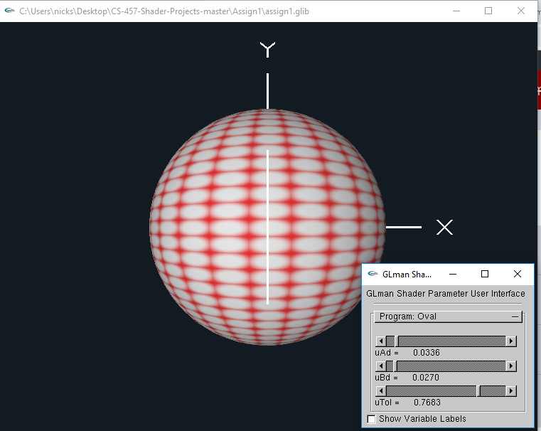

Video Link: <https://media.oregonstate.edu/media/t/0_d7tvqlg9>

Thanks, and have a great day!